Lab 13

Project : Faculty Feedback Analysis
Technology-Stack: ML + Django
Database schema {admin, organizational-users, teacher/faculty, student, comments/text.
Technique: (Machine learning, NLP, Dashboard Analytics, Word-Cloud, Performance Matrix for Teachers)
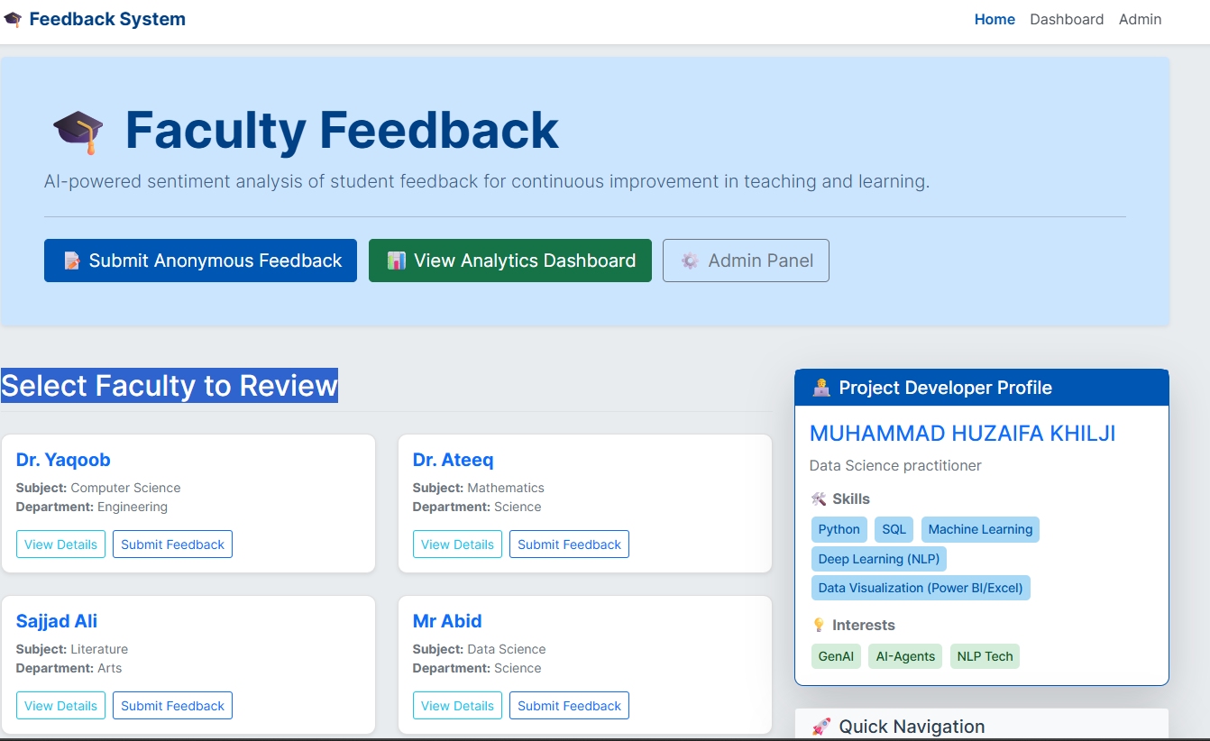

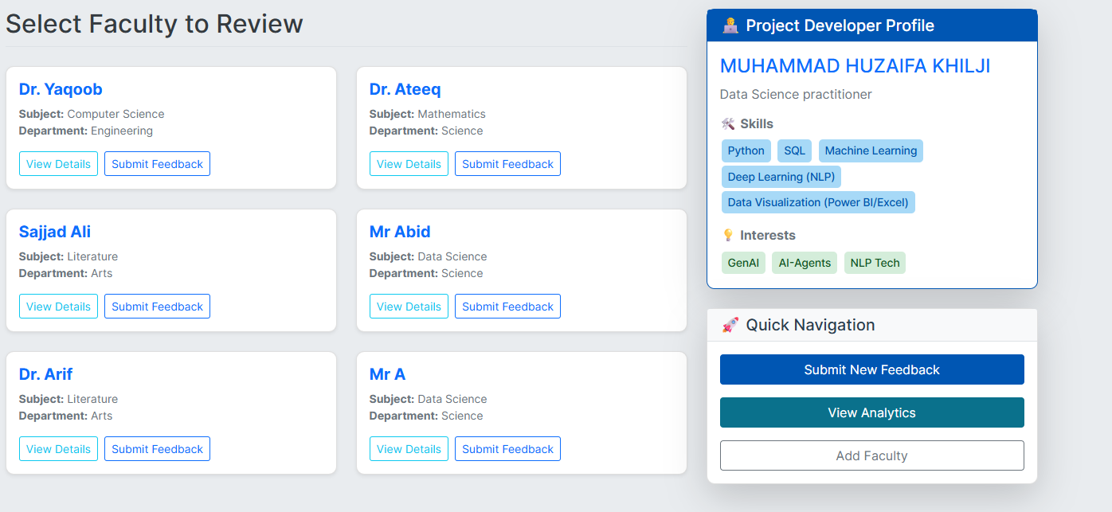
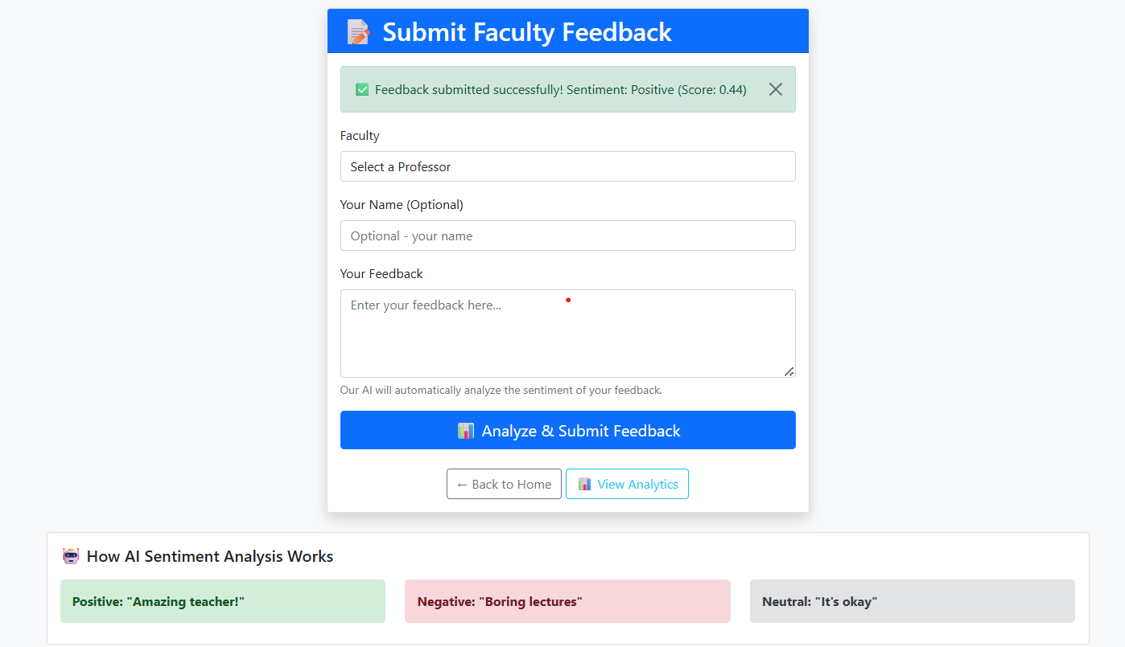

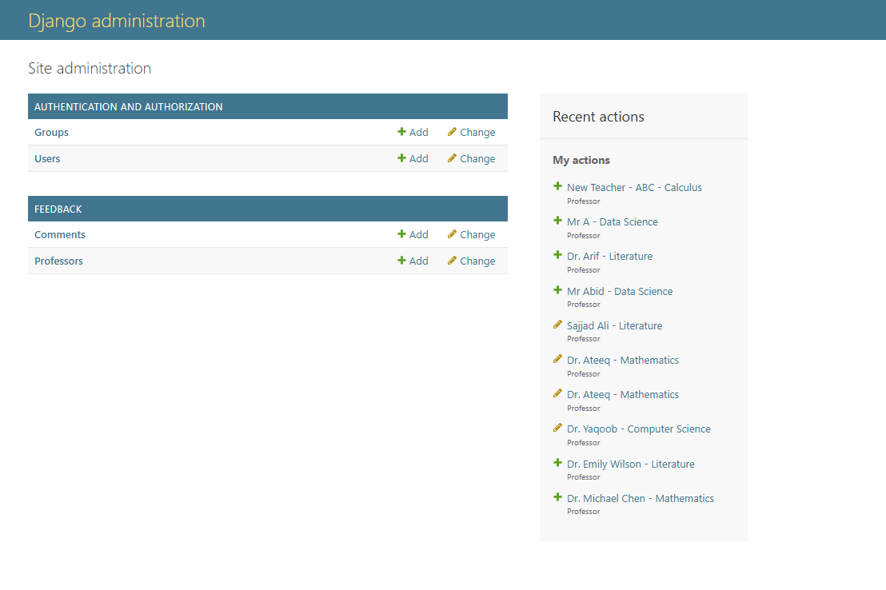
Backend to handle Database for :
Faculty Members
Students
Admin (Operators)/Organizational Users
